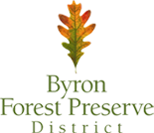
Are You Ready for Preschool Checklist:

- Most current copy of child’s Physical-Including shot records and health history signed by parent and doctor.

- Byron Forest Preserve Registration paperwork- completed with current contact information and payment authorization for upcoming school year.

- School Supplies – No labeling necessary

- A REGULAR sized backpack, facemask and take home folder labeled with child’s first and last name.

- If you would like to order a preschool t shirt and/or facemask please see link: Unavailable at this time ONLINE ORDERS ONLY. Your items will be passed out at school.

- A complete change of clothes to keep in child’s backpack

